Web 1.0, 2.0 and 3.0
Web 1.0: it refers to the first stage in the World Wide Web. It is made of web pages that are connected by hyperlinks. A hyperlink is a link from a hypertext file.


Web 2.0: is the name that is given to help describe the 2nd generation of the World Wide Web. The goal of Web 2.0 is mainly about transmitting people the ability to collaborate and share information online.

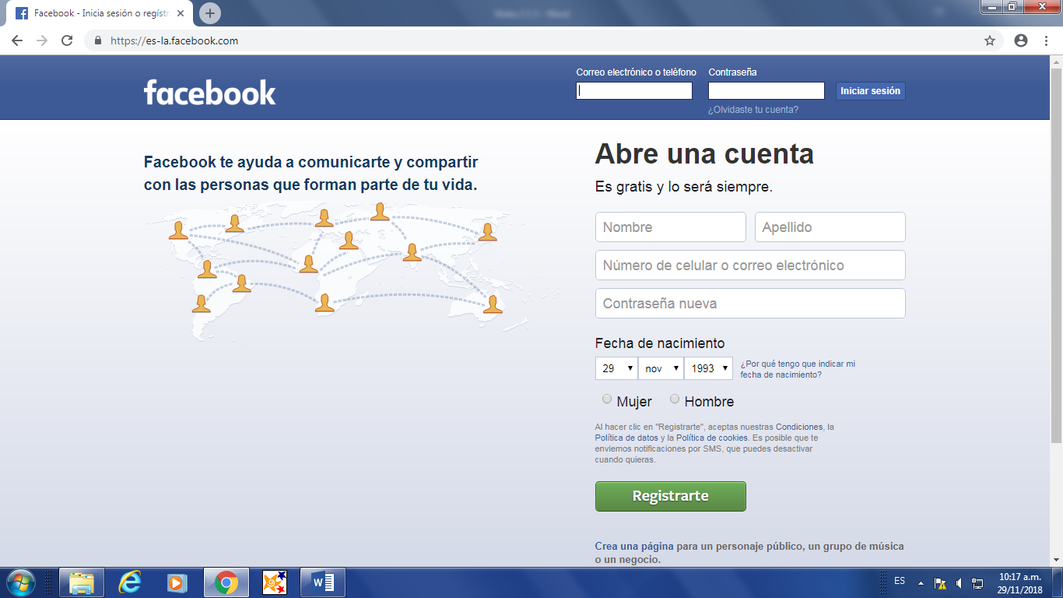

Web 3.0: will mark a basic change of how do developers create websites. It is a new program to be the new model in the web interaction.
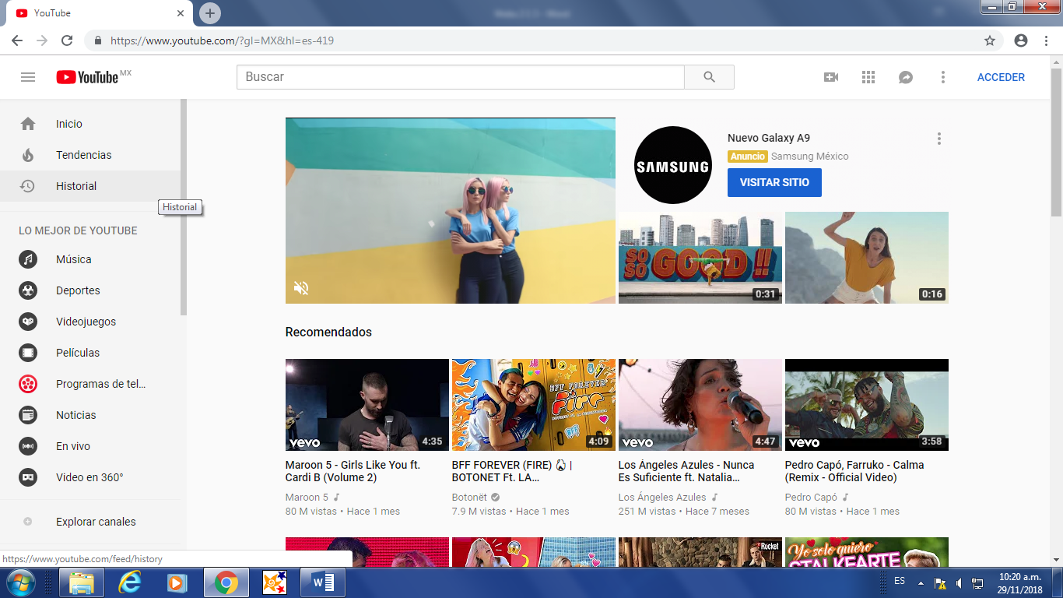
Web 4.0: is an open and intelligent web. Web 4.0 loads web pages quicker and with better results than others. According to many computer engineers web 4.0 will be comparable to human brains. Its goal is the interaction between humans and machines in collaboration.
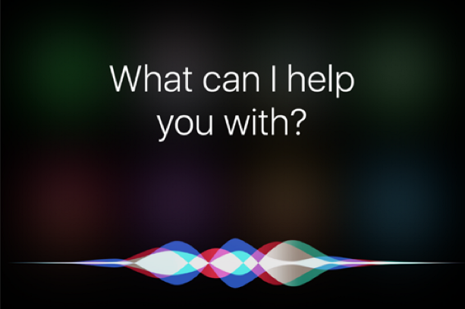

References
“Web 1.0”. Techopedia. https://www.techopedia.com/definition/4923/web-30 (November 26, 2018).
“Web 2.0”. Techopedia. https://www.techopedia.com/definition/4923/web-30 (November 26, 2018).
“Web 3.0”. Techopedia. https://www.techopedia.com/definition/4923/web-30 (November 26, 2018).
“Web 4.0”. Stephen Letts. https://stephenletts.wordpress.com/web-4-0/ (December 3, 2018).

